**GDSC PIEAS Web Development Bootcamp**

*Assignment No: 2*

*Name: Abdul Rehman*

*Email:* [*bc220424444are@vu.edu.pk*](mailto:bc220424444are@vu.edu.pk)

**Solution Code:**

**HTML Code:**

<!DOCTYPE html>

<html lang="en">

<head>

  <meta charset="UTF-8">

  <title>Abdul Rehman Portfolio Website</title>

  <link rel="stylesheet" href="style.css">

</head>

<body>

  <header>

      <nav>

        <ul>

          <li><a href="#home">Home</a></li>

          <li><a href="#about">About</a></li>

          <li><a href="#contact">Contact</a></li>

        </ul>

      </nav>

  </header>

  <main>

    <section id="home">

        <h1>Hi, I'm Abdul Rehman</h1>

        <p>from GDSC VU.</p>

    </section>

    <section id="about">

        <h1>About Me</h1>

        <img src="https://media.licdn.com/dms/image/D4D03AQHrZgJJQnNzcA/profile-displayphoto-shrink_200_200/0/1685016738220?e=1709164800&v=beta&t=65e5T2rL2C6xwqXDEsmhxRs0T5gllI4Dyxfhz5TWUfE" alt="profile pic">

        <p>Hi, my name is Abdul Rehman and I am a Professional Frontend Web Developer and Video Editor. I completed more than 50 projects and the technologies I'm currently working on are HTML, CSS, JavaScript, Bootstrap, PHP and MERN Stack. Being a Web Developer I am creating and designing a beautiful Websites.</p>

    </section>

    <section id="contact">

        <h1>Contact Me</h1>

        <button>Send me an email</button>

    </section>

    <p>Copyrights Reserved.</p>

  </main>

</body>

</html>

**CSS Code:**

body {

    margin: 0;

    font-family: 'Arial', sans-serif;

}

nav ul {

    margin: 0;

    list-style: none;

    text-align: center;

}

nav ul li {

    display: inline;

    margin: 0 20px;

}

nav ul li a {

    color: black;

    text-decoration: none;

    font-weight: bold;

}

main {

    padding: 20px 0;

    text-align: center;

}

#home{

    padding: 100px 0;

    background-color: rgb(5, 32, 41);

}

#home h1{

    font-size: 30px;

    color: rgb(57, 247, 57);

}

#home p{

    color: white;

}

#about{

    padding: 100px 0;

    color: rgb(5, 32, 41);

    background-color: rgb(57, 255, 57);

}

#about img{

    border-radius: 100%;

}

#about p{

    padding-left: 400px;

    padding-right: 400px;

}

#contact{

    padding: 100px 0;

    background-color: rgb(5, 32, 41);

}

#contact h1{

    color: rgb(57, 247, 57);

}

**Coding Screenshot:**

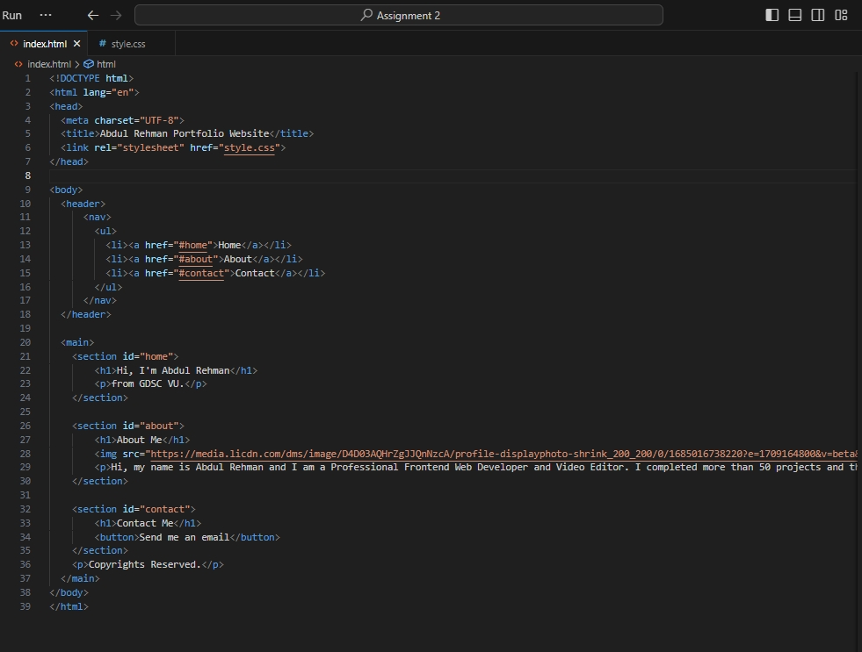

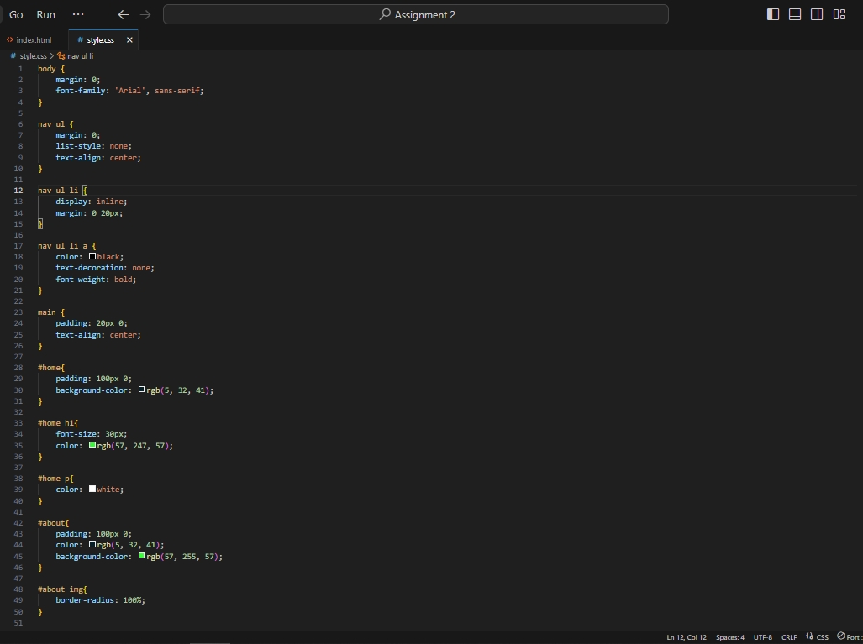

**Output Screenshot:**

